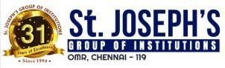 

**Placement Empowerment Program**

***Cloud Computing and DevOps Centre***

60 Days of DevOps Challenge

***Day 3: Git & GitHub - Basics, Branching, Merging, PRs***

***Name: Mary Edlyn A Department: CSE***



This PoC will showcase **how to automatically provision and manage EKS (Elastic Kubernetes Service) clusters on AWS** using Infrastructure-as-Code and automation tools

**Challenge 1**: Fork and clone an open-source project ([Sample Project Link](https://github.com/sd031/eks-auto-mode-workshop?_bhlid=191771b5fb5ee790e5bb7b36a456ffd489a266a3&ref=learnxops.com))

**Challenge 2**: Create a new branch (feature-branch), switch, and commit changes.

